A PROJECT REPORT ON
File Utility App

SUBMITTED TO THE SAVITRIBAI PHULE PUNE UNIVERSITY, PUNE IN THE PARTIAL FULFILLMENT FOR THE AWARD OF THE DEGREE

OF

BACHELOR OF BUSINESS ADMINISTRATION IN
COMPUTER APPLICATION

BY

Karn Gopal Gaikwad

 |  | INDEX
Sr.No |  | Chapter Name | PageNo.
1 |  | Abstract | I
2 |  | Introduction | 3
 | 2.1 | Motivation
 | 2.2 | Problem Statement
 | 2.3 | Purpose/Objective and Goals
 | 2.4 | Literature Survey
3 | 2.5 | Project Scope & Limitation  System Analysis | 5
 | 3.1 | Existing System
 | 3.2 | Scope and Limitations
 | 3.3 | Perspective and Features
 | 3.4 | Stakeholders
4 | 3.5 | Requirement Analysis  System Design | 8
 | 4.1 | Design Constraints
 | 4.2 | System Model: DFD
 | 4.3 | Data Model
5 | 4.4 | User Interfaces  Implementation Details | 22
 | 5.1 | Software Requirements
 | 5.2 | Hardware Requirements

6 |  | Outputs and Report Testing | 24
 | 6.1 | Test Cases
 | 6.1.1 | Black Box Testing
 | 6.1.2 | White Box Testing
7 |  | Conclusion & Recommendations | 33
 | 7.1 | Conclusion
 | 7.2 | Recommendations
8 |  | Future Scope | 35
9 |  | Bibliography & References | 37

CHAPTER 1: ABSTRACT

ABSTRACT

File Utility App is an all-in-one website that helps you convert files quickly and easily. Whether you need to change a PDF to Word, PowerPoint to PDF, or even convert images and videos, this app has you covered. You don’t need multiple tools—everything you need is in one place.
The app is designed to be simple, user-friendly, and open to everyone. All you have to do is sign up, log in, choose the type of conversion you need, upload your file, and download the converted version right away. No long waits or complicated steps.
Behind the scenes, the app uses Python to handle the file conversions and PHP to run the website. It only stores your login information—your files are never saved or shared, ensuring your data stays private and secure on your own device.
Whether you're a student working on assignments, a professional dealing with documents, or just someone who needs to convert a file quickly, File Utility App makes the process fast, easy, and stress-free.
.

CHAPTER 2: IMTRODUCTION

  - Motivation
Most online file tools are either paid, limited, or unsafe for privacy. Many users, especially students, struggle to find a free, simple, and secure tool. This project was developed to solve this issue by creating a single open-source platform performs multiple file operations without ads or restrictions.
  - Problem Statement
Today’s users often struggle with having to use multiple tools or websites to convert different file types. Many of these tools are either limited, paid, or come with privacy concerns—storing or tracking users' files without clear consent. There is a clear lack of a single, unified, and secure platform that offers free file conversion for formats like PDF, Word, PowerPoint, Excel, images, and videos—all without saving or exposing sensitive data.
  - Purpose/Objective and Goals

Purpose / Objective:

The main purpose of the File Utility App is to offer a centralized, secure, and easy to-use platform where users can convert different types of files-such as PDFs, Word documents, Excel sheets, PowerPoint presentations, images, and videos without needing multiple tools. The app is designed to be open-source, free from ads, and simple enough for anyone to use. By using Python libraries for backend processing, all file conversions are handled safely, without storing user files on the server. The objective is to create a trusted tool that respects user privacy while offering convenience, speed, and versatility.

Goals:
- Provide a centralized platform for various file conversion and utility tasks.
- Ensure the tool remains open-source, ad-free, and easy to use.
- Allow users to create accounts to access and manage multiple conversion tools.
- Perform all conversions locally using Python libraries to protect user data.
- Support a wide range of common file formats (PDF, Word, Excel, images, videos).
- Maintain fast and reliable performance with minimal user wait time.

  - Literature survey
There are many tools available for working with documents, each with pros and cons. Adobe Acrobat DC is a powerful tool for editing and managing PDFs, but it requires a paid subscription. Websites like ILovePDF and SmallPDF offer free services, but they have limited features and often show ads. LibreOffice is a free alternative that supports many file types, but it can be confusing for beginners and does not work well online. Some Python libraries such as pypdf, python-docx, PIL, pandas, and pydub are also useful. They are free and offer strong tools for document processing, but they require some coding skills. Each tool has its own use depending on what the user needs and how comfortable they are with technology.
  - Project Scope and Limitations

Project Scope:
In the future, the system can be improved by adding more features and tools to make it even more useful. Some possible additions include watermarking, file compression, and file merging or splitting options. Support for more file formats can also be added to make the tool more flexible. A cloud storage option can help users save and access their files online. Improving the user interface and adding support for multiple languages can make the system easier to use for a wider audience. With regular updates and feedback from users, the system can continue
to grow and become a complete file management solution.

Project Limitations:
The File Utility App has a few limitations.
- Its performance depends on the server, so large files may take more time to convert.
- The app does not support cloud storage, and all file operations are done locally.
- It has limited multi-user handling on small servers and currently offers only basic file conversions.
- Features like compression, watermarking, and drag-and-drop upload are not yet included.

CHAPTER 3: SYSTEM ANALYSIS

  - Existing Systems
Compared to existing solutions, this project offers a lightweight and accessible alternative. Adobe Acrobat, while reliable and feature-rich, is paid and resource-heavy, making it less ideal for quick or casual use. Online tools like ILovePDF and PDFCandy provide useful features but often come with usage limits and are not open-source, restricting flexibility and transparency. LibreOffice CLI is a free and powerful option but lacks a user-friendly web interface, which can be a barrier for non-technical users. This project aims to bridge these gaps by offering a free, simple, and open-source solution with a web-based interface.
    - ILovePDF
    - PDFCandy
    - LibreOffice

  - Scope and Limitations of Existing Systems
Most existing tools are limited in scope, often focusing on a single task such as PDF conversion or image editing, without offering a unified solution. Additionally, many platforms are filled with ads, require payments for full access, or enforce login restrictions, which reduces overall user-friendliness. A major limitation is the lack of integration between different media types—document, image, and video tools are usually offered separately, making it inconvenient for users who need a more comprehensive, all-in-one solution.
  - Project Perspective and Features

Project Perspective:
This project is designed to be simple, flexible, and easy to manage. Each tool is built as a separate Python script, so changes or new tools can be added without affecting the whole system. The frontend is made using PHP, which works well with XAMPP and shared hosting, making it easy for students, teachers, and small organizations to use. The goal is to create a useful tool that doesn’t need a powerful server or complex setup.

Project Features:
The project has a clean and easy-to-use interface made with Bootstrap, so it works well on computers, tablets, and phones. Users just need to log in, pick a tool, upload a file, and download the result—it's that simple. It combines tools for working with documents, images, and videos all in one place, so there’s no need to visit different websites. The project is open-source, meaning anyone can help improve it. It's free, fast, and useful for both everyday users and professionals.
  - Stakeholders
This project serves a wide range of users with specific needs. Students benefit from free conversion tools that assist in preparing assignments and projects without additional costs. Teachers and staff can quickly prepare course materials, saving time and effort. Professionals use the platform to handle document conversions without the need to purchase expensive software. Additionally, the open-source community can contribute by extending and improving the project, making it more versatile and widely accessible.
  - Requirement Analysis

Functional Requirements:
- User signup/login/logout system.
- Dashboard with multiple tool options.
- File upload and secure storage.
- Run Python scripts for file conversions.
- Return output files for download.

Performance Requirements
- Uploads should complete quickly
- Scripts must not use too much CPU or memory.
- Errors should be shown immediately.

Security Requirements
- Password protection
- Save uploads only in a non-public directory

- Only specific file formats allowed.

CHAPTER 4: SYSTEM DESIGN

  - Design Constraints:
User Table:

Field | Type | Null | Key | Default | Extra
id | int(11) | NO | PRI | NULL | auto_increment
name | varchar(50) | NO |  | NULL
email | varchar(100) | NO | UNIQUE | NULL
password | varchar(10) | NO |  | NULL
phone | Varchar(10) | YES |  | NULL
Created_at | timestamp | YES |  | CURRENT_  TIMESTAMP

Admin:
Field | Type | Null | Key | Default | Extra
id | int | NO | PRI | NULL | auto_increment
user_name | varchar | YES | UNIQUE | NULL
password | varchar(10) | YES |  | NULL

Feedback:
Field | Type | Null | Key | Default | Extra
id | int | NO | PRI | NULL | auto_increment
user_id | int | NO |  | NULL
user_name | varchar(100) | NO |  | NULL
feedback | text | NO |  | NULL
admin_reply | text | YES |  | NULL
Created_at | timestamp | YES |  | CURRENT_TIMESTAMP

Notification:
Field | Type | Null | Key | Default | Extra
id | int | NO | PRI | NULL | auto_increment
message | varchar | YES | UNIQUE | NULL
Created_at | timestamp | YES |  | CURRENT_TIMESTAMP

  - System Model :

    - Zero level:

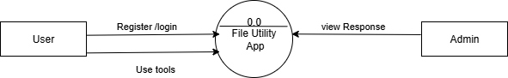

    - One level:

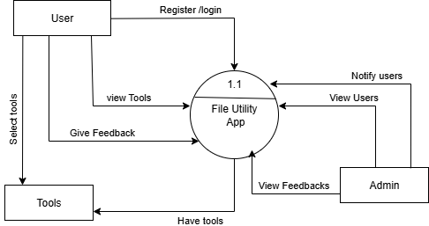

ss
  - Data Model:
    - ER Diagram:

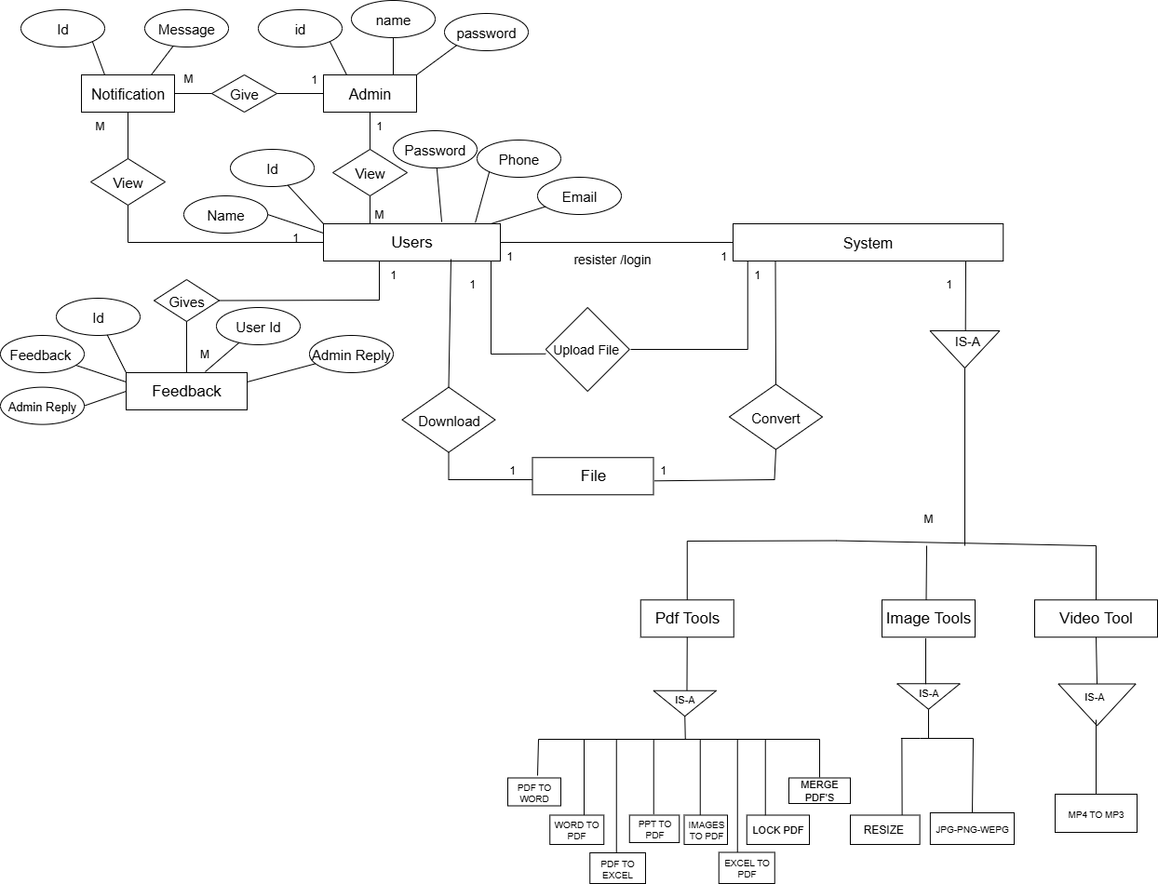

    - Class Diagram:

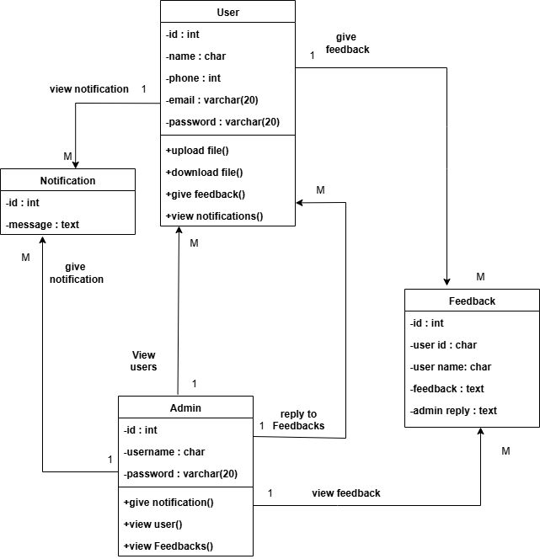

BBA (COMPUTER APPLICATION) 2025-2026

    - Use Case Diagram:
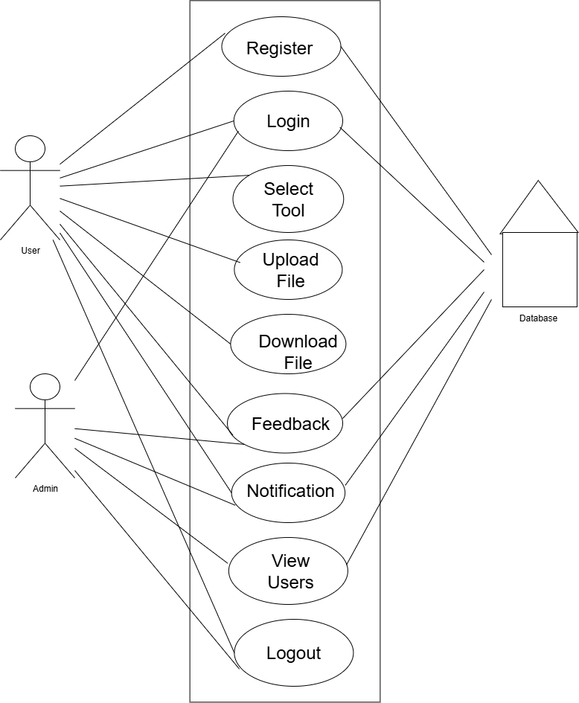

    - Activity Diagram:
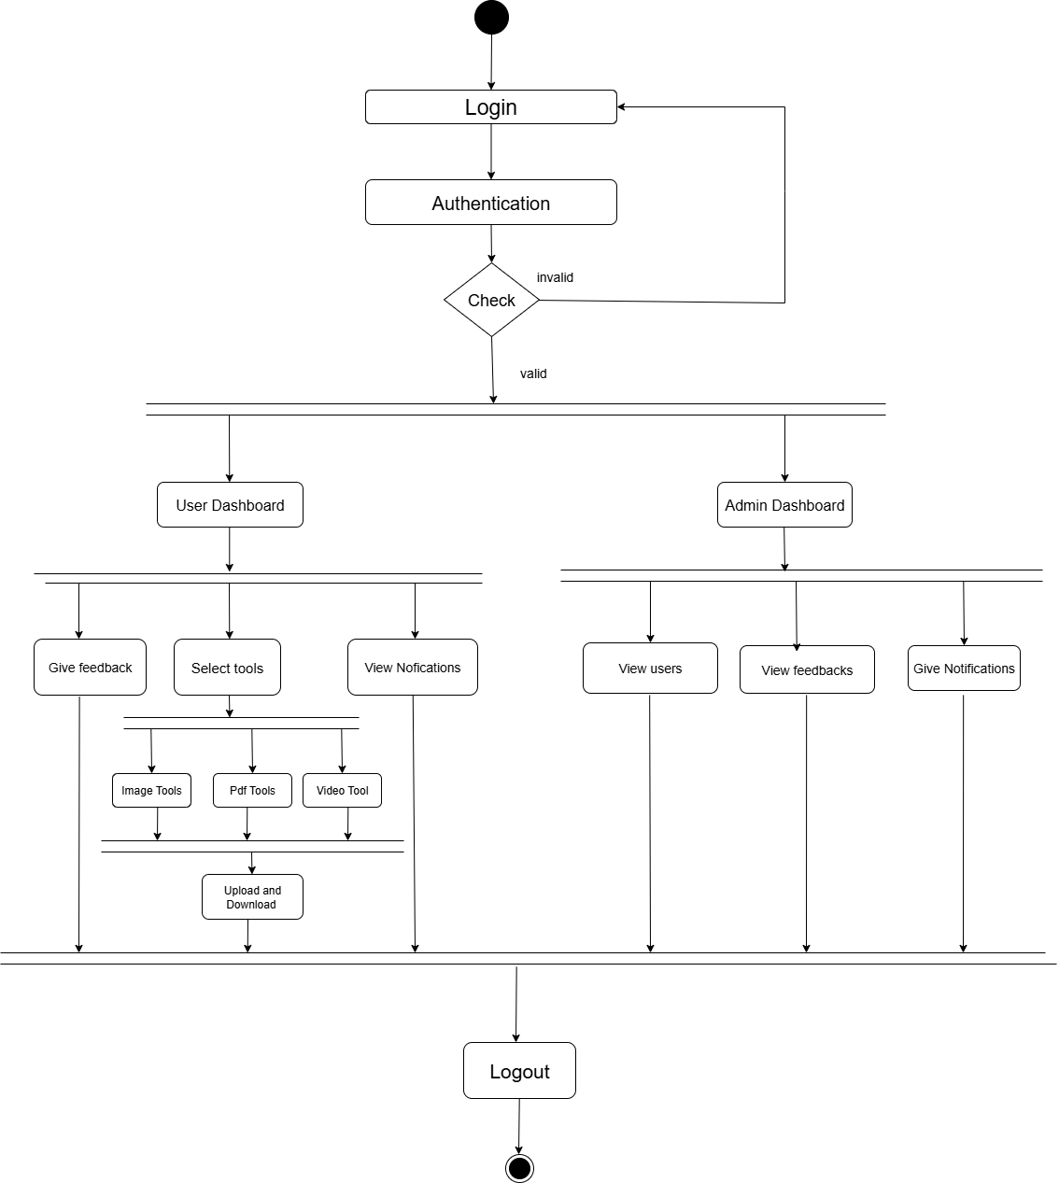

    - Sequence Diagram:
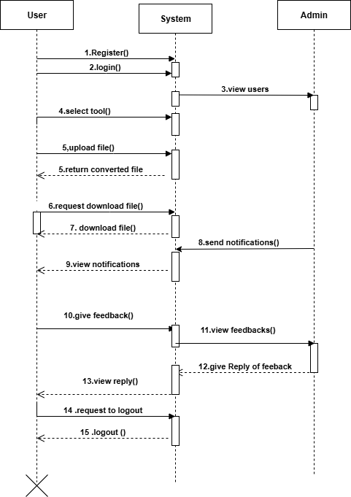

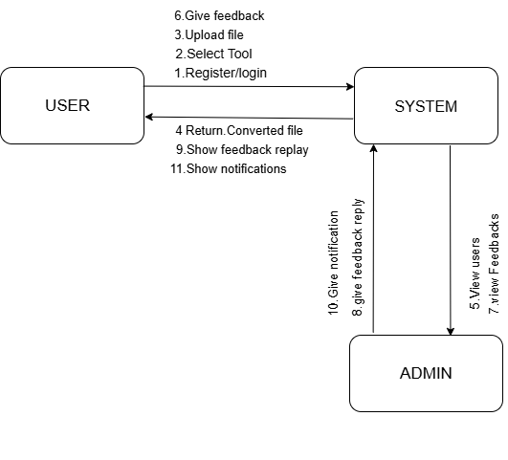
    - Collaboration Diagram:

4.3.7Deployment Diagram:

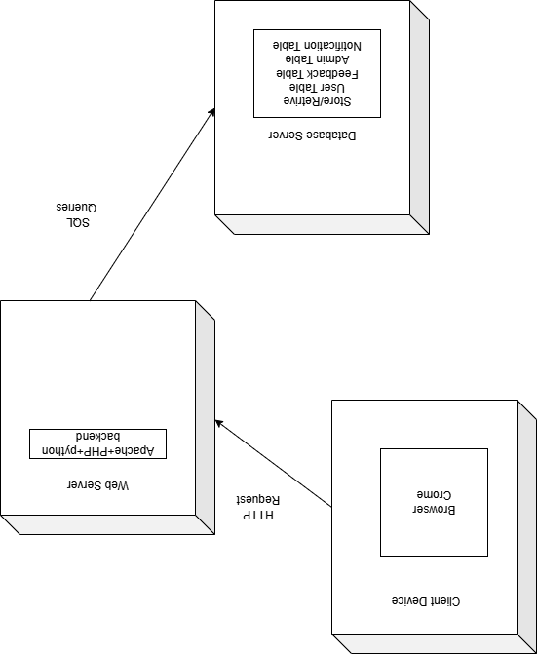

  - User Interfaces:
4.4.1 user Register

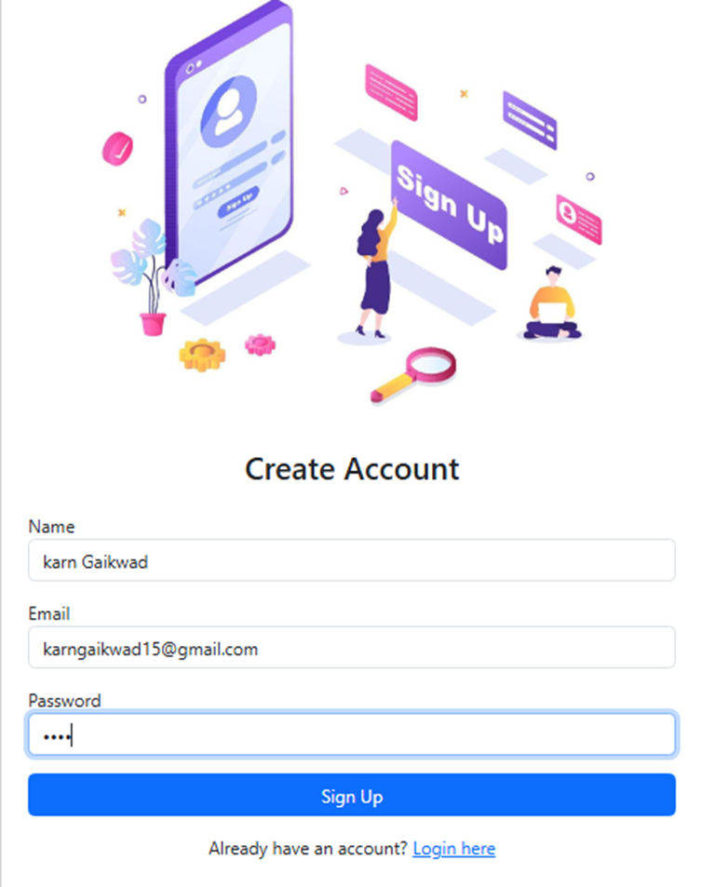

4.4.2 User login
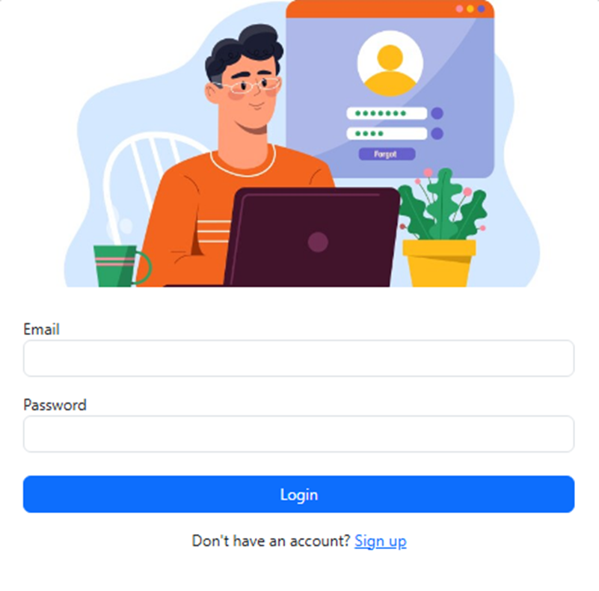
4.4.3 Dashboard

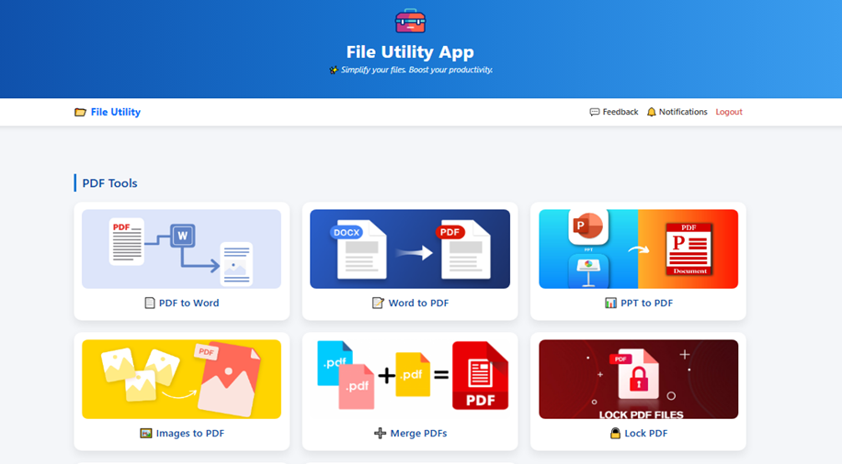
    - upload file

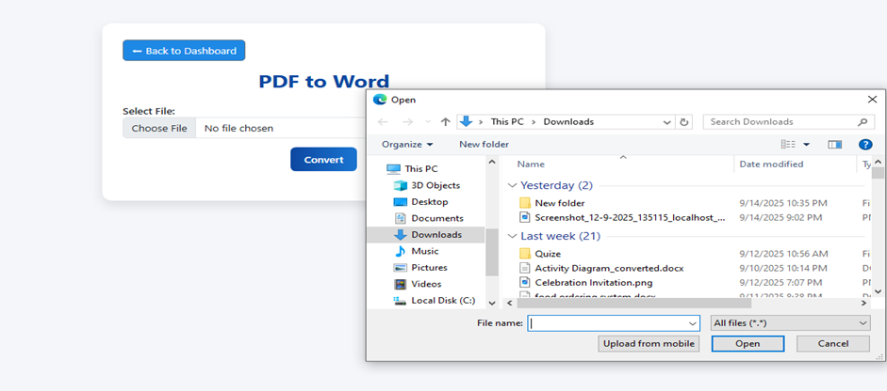
4.4.5 Feedback:

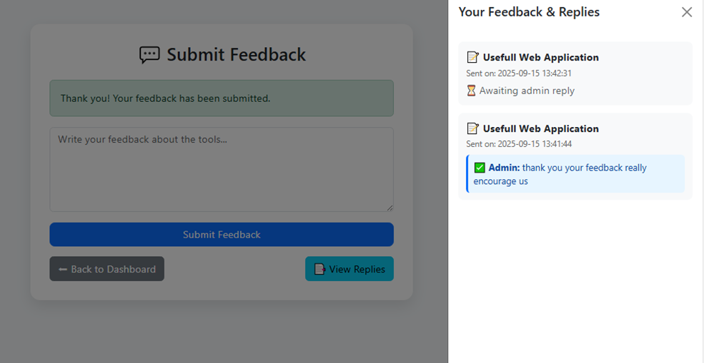

CHAPTER 5:
IMPLEMENTATION DETAILS

  - Software Requirements;

- OS: Windows
- Web Server: XAMPP (Apache + MySQL)
- Languages: PHP, HTML, CSS, Python.
- Database: MySQL
- Required Python Libraries:
  - Pandoc,reportlab,docx2pdf,win32com.client,pdfplumber etc..

  - Hardware Requirements:

    - Processor: Intel i3 or higher
    - RAM: 4 GB or above
    - Storage: 100 GB free space
    - Display: 13-inch or larger screen
    - Input Devices: Keyboard and Mouse

CHAPTER 6: OUTPUTS AND REPORTS TESTING

  - Test Plan
    - Black Box Testing:

Test Case ID | Test Description | Preconditions | Test Steps | Expected Results | Actual Results | Status | Remarks
TC-01 | Register User | User is on registration page | 1. Enter valid Name, Email, Password  2. Click Register | User should be created successfully | User created successfully | Pass | Works as expected
TC-02 | Login User (Invalid) | User account exists | 1. Go to login page  2. Enter valid Email and invalid Password  3. Click Login | Error message should be displayed | Error message displayed correctly | Pass | Validation handled properly
TC-03 | Select tool and upload file | User is logged in | 1. Go to Upload select invalid file  2. Hit convert button | Error shows invalid file type | Error message displayed correctly | Pass | Valid File types working
TC-04 | Tool Selection | User is on homepage | 1. Click on one tool option | Display selected tool upload screen | Upload file screen displayed | Pass | Categories loading fine
TC-05 | Feedback | User is on view the feedback and admin reply | 1. Click on "View reply | Show the reply | The reply and feedback displayed | Pass | Works correctly

TC-1:
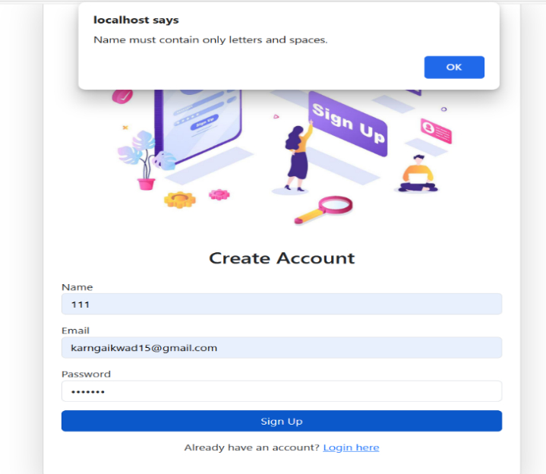

TC-02:
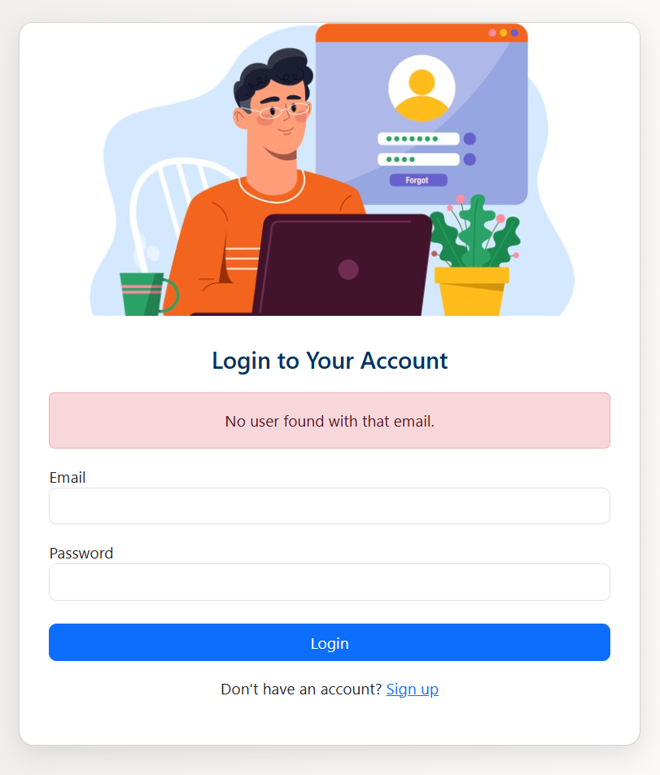
TC-03:
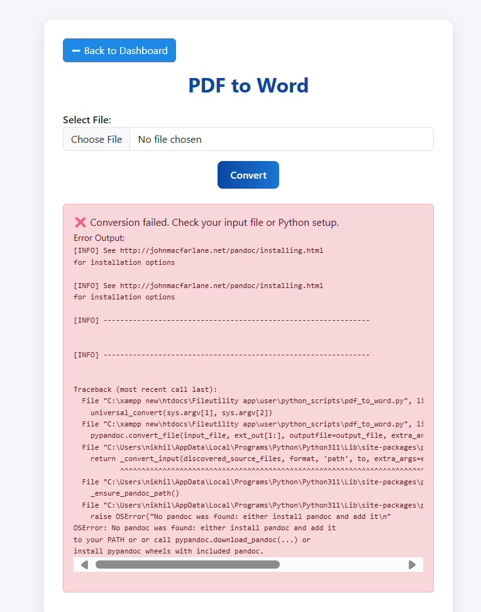

TC-04:
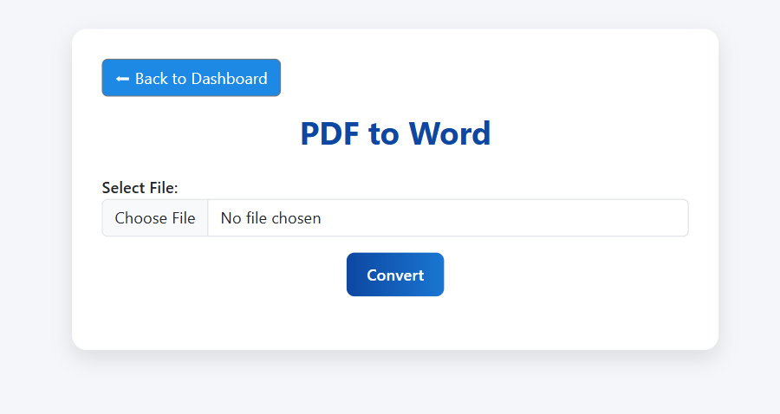

TC-05:
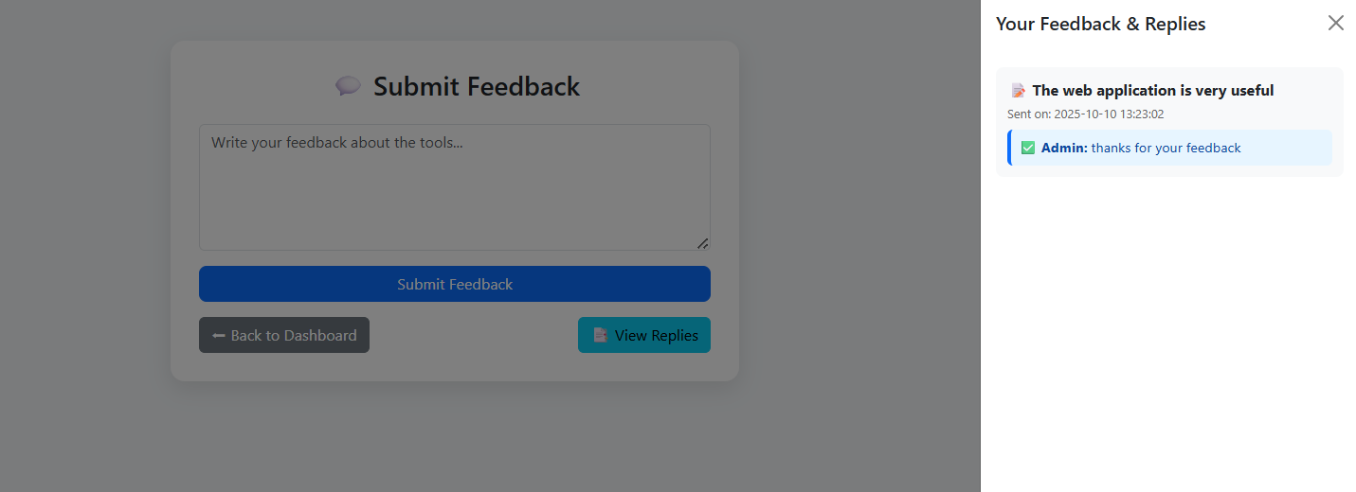

    - White Box Testing:
Test Case ID | Module | Logic Tested | Technique Used | Expected Result | Status
TC- 01 | User Login | Verifies if user credentials are validated correctly (if(email && password match)) | Branch Coverage | Valid credentials allow login; invalid credentials show error | Pass
TC- 02 | Admin login | Checks condition for valid username and password before submission | Condition Coverage | Form submits only with valid data | Pass
TC- 03 | Admin Dashboard | Ensures all data fetching loops run  properly (for each user in list) | Statement Coverage | All User  records displayed | Pass
TC- 04 | User  Registration | Checks all required field validations  (if(name != '' @@ email != '' && password !=  '')) | Condition Coverage | Registration only proceeds when all fields are filled | Pass

TC-01:
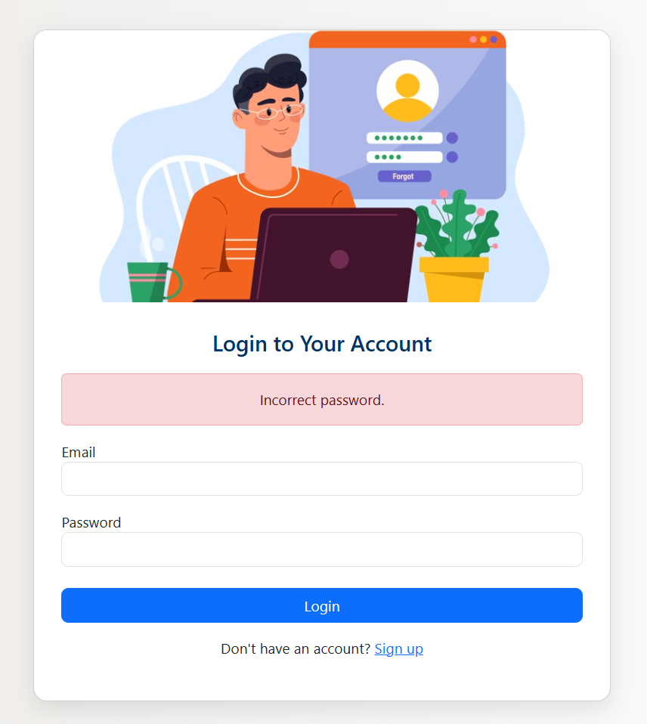

TC-02:

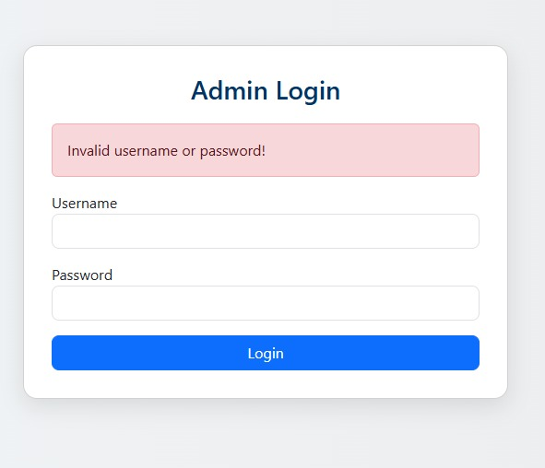

TC-03:

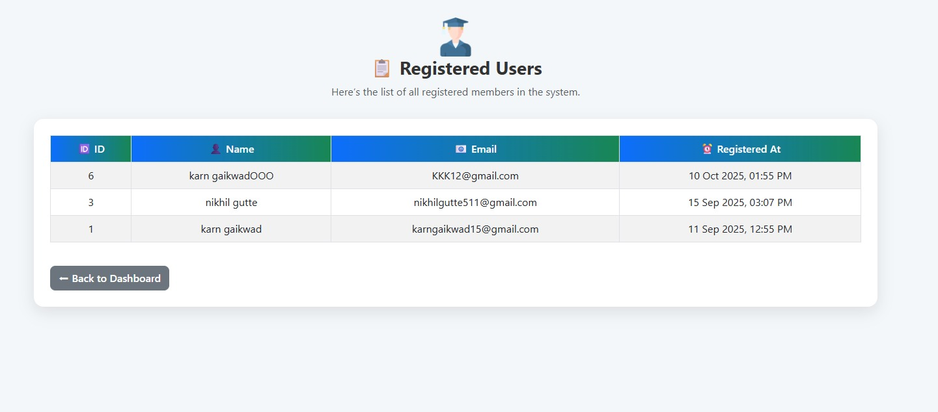

TC-04:

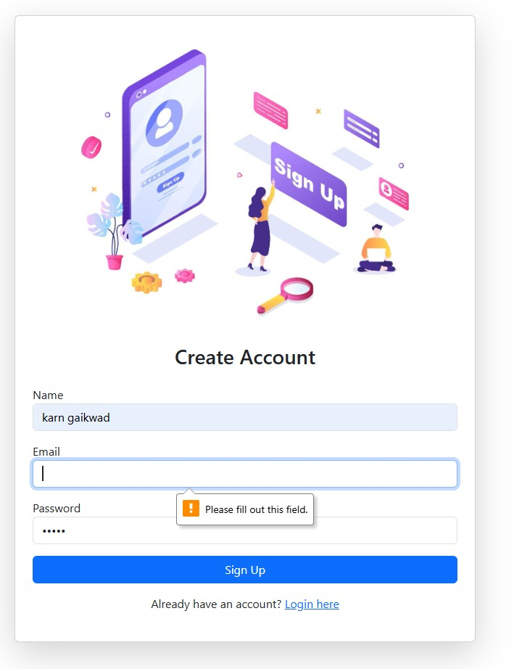

OUTPUT SCREENS:

User Dashboard

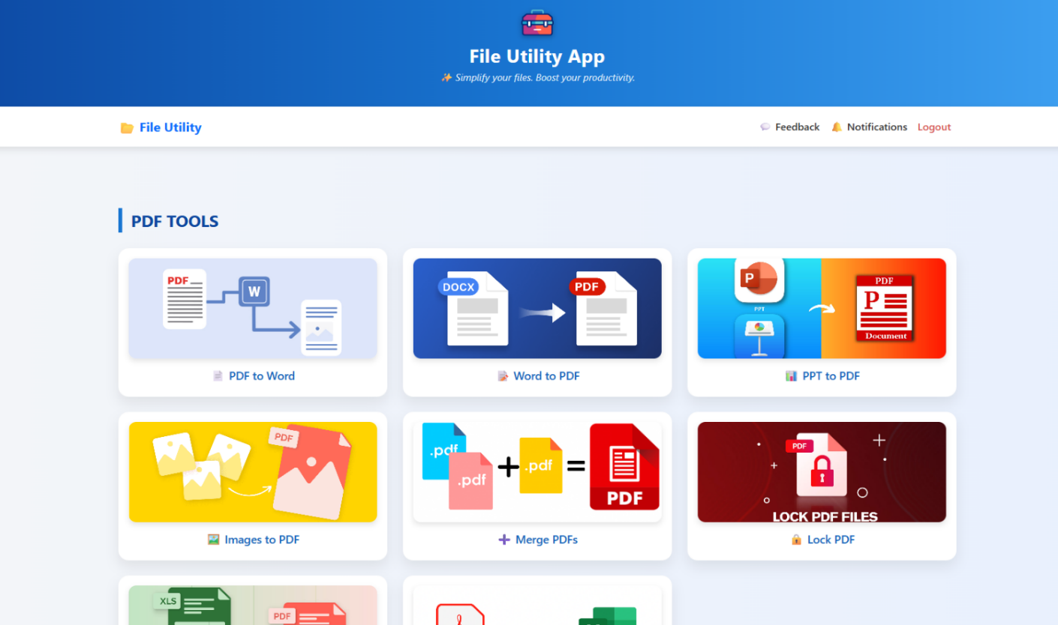

User Feedback



Download file

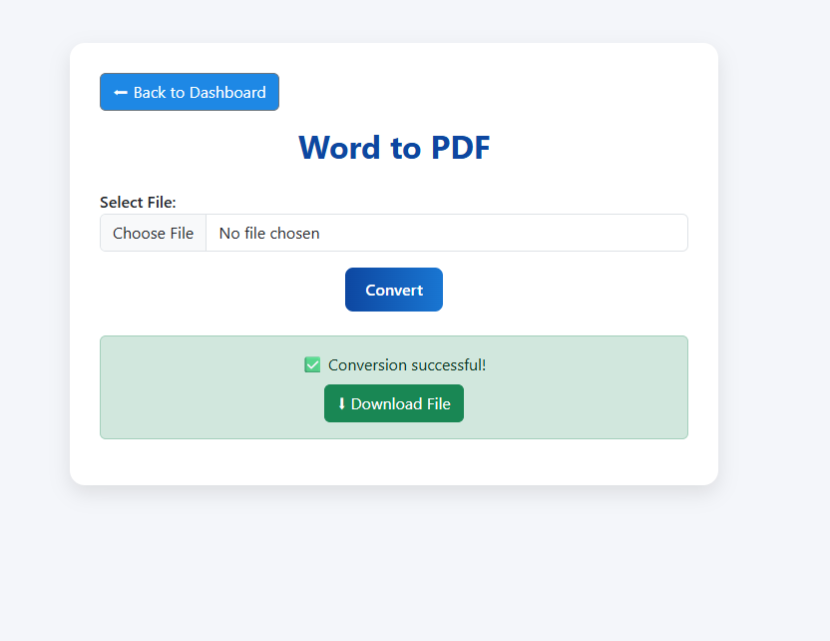

View Notifications

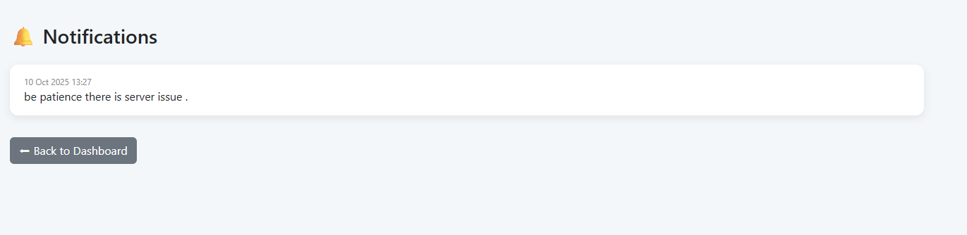

CHAPTER 7: CONCLUSION AND
RECOMMENDATIONS

  - Conclusion
The File Utility App provides a simple and effective solution for everyday file conversion needs. It helps users perform quick file conversions without relying on expensive or complicated software. With its easy-to-use interface, straightforward workflow, and open-source design, the app is suitable for students, teachers, and professionals who need fast and reliable file tools.
  - Recommendations

To improve the app further, a few key features are recommended. Adding a progress bar or loading animation would give users better feedback during large file conversions. Drag-and-drop support would make file uploads quicker and more convenient. Enhancing error handling for very large or corrupted files would make the app more stable. Lastly, supporting more file formats.

CHAPTER 8: FUTURE SCOPE

8.1 Future Scope:

    - Add support for converting HTML to PDF.
    - Include a zip/unzip file utility.
    - Provide multi-language support for global users.
    - Implement drag-and-drop file uploads for ease of use.
    - Add watermarking and PDF compression features.
    - Integrate cloud storage to save and access files online.
    - Add AI-based file optimization for faster performance.
    - Introduce dark mode for better user experience.
    - Create a mobile-friendly version for smartphone users.
    - Improve security with file encryption and role-based access.

CHAPTER 9: BIBLIOGRAPHY AND REFERENCES

9.1 References

- iLovePDF.com — Tool inspiration and user interface ideas.
- W3Schools.com — PHP, HTML, CSS -www.w3schools.com
- PyPI.org — Official Python libraries PyPDF2, Pillow etc.- https://pypi.org/
- Chatgpt – debug and error solving -https://chatgpt.com.

